Accounting Software Report
Student’s Name
Institutional Affiliation

Transmittal Letter
Your Address
City, State, Zip Code
Phone Number
Accounting Software Project
11/02/2019

Director of Accounting,
Extreme Technologies, Inc.,
1411 Avenue A
Katy, TX 77493
Houston, TX.
Attention: Mr. Jack Joseph
Analysis and Recommendation of Accounting Software
I have completed an analysis of the various accounting software and made a recommendation on the best software that can be acquired for business use. The analysis was in line with the earlier proposal as verified by your office.
The analysis involved five key software that was narrowed down to FreshBooks and Sage 50cloud. The two software had similar functionalities like the other software but were unique for its additional functionalities that would be of benefit to the company. The two offer excellent payment checkout as well as capabilities of monitoring payments from the bank.
Thank you for taking the time to review the proposal. The report has been attached for your perusal.
Sincerely,
(Signature)
(Your Name)
(Title)
Table of Contents
Executive Summary 4
Introduction 5
Purpose 5
Description 5
Scope 5
Discussion 6
FreshBooks 6
Comparison of FreshBooks with the other accounting software 6
Sage 50cloud 7
Comparison of Sage 50cloud with the other accounting software 7
Conclusion and Recommendation 7
References 9
Appendix……………………………………………………………………………………….. 10

Executive Summary
Accounting is an important aspect of any business organization. the ability to efficiently manage financial records not only helps the company to monitor progress but also make financial decisions. Automation of accounting processes through the use of accounting software is a norm in the current marketing environment. The report provides an analysis of two accounting software FreshBooks and Sage 50cloud and its suitability for use within the business. a comparison with other software in the market is done, and a conclusion that provides a recommendation on the two is provided.

Introduction
Accounting software is a critical system of any enterprise regardless of their size or industry. The popularity, as well as the use of the software, can be attributed to the benefits it offers. The advantages of the accounting software include faster accounting, lowered cost, as well as error-free taxation (Hall, 2015). Presently, there is a wide range of accounting software with varying features and capabilities that companies can choose from. The companies usually select an accounting system that has an attractive interface and is user-friendly (Fadzilah, 2017).
Thesis statement: There are several fitting accounting software programs currently on the market that would be beneficial to the company as it advances. FreshBooks and Sage 50cloud are two of the top accounting software programs that can increment productivity.
Purpose
The purpose of the report is to recommend the latest accounting software programs on the market with the objective of replacing the old software used in the company.
Description
Various available materials about the latest accounting software were reviewed, and various accounting software analyzed and compared against each other. This comparison allowed for the differences and the roles of the software in accounting activities to be identified. Based on the findings from the literature review, the best latest accounting software was recommended to replace the old software used by the company presently.
Scope
The scope of the proposal will revolve around accounting software and their importance to the accounting practice. The proposal will also cover the features of the latest accounting software, their differences, as well as their roles in accounting activities.
Discussion
There are several good quality accounting software with varying features and capabilities available in the market. Therefore, selecting the right can be challenging (Lam, 2015). A company must choose a software that meets its business needs as well as available resources within the organization.
There are various accounting softwares that can be choose by the organization depending on their needs. Some of the leading software available in the market include NetSuite ERP, FreeAgent, Zoho Books and Xero (Simkin, Rose & Norman). The software’s are almost similar to FreshBooks and Sage 50cloud but are different in a way. They offer numerous tools including marketing automation which allows the company to track sales as well as make marketing decisions.
FreshBooks
FreshBooks is developed and marketed by2ndsite Inc. The software offers cloud-based accounting functions that manage payroll and pay bills applications. It is also fashioned mainly toward small and medium-sized businesses. the software automates payment systems as well as allows a check out to numerous payment solutions such as PayPal and Amex. The software can also be used to manage invoices and other expenses which has given it an approval rating of 99% among the customers.
Comparison of FreshBooks with the other accounting software
FreshBooks differs with the other software slightly based on its capabilities. However, they almost conduct the same functions but FreshBooks provides for mobile application and integration into other applications. Besides, majority of its features have been retained making it easier and compatible to businesses that have always relied on this software.
Sage 50cloud
Sage 50cloud is cloud-based accounting software designed for small enterprises as well as medium-sized ones. The software provides features such as invoicing, cash flow, budgeting, inventory, and taxes. The software also supports various add-ons for payroll, credit card processing and much more. The major benefits associated with Sage 50cloud include less administration, faster payments, as well as more productivity (Mantovani, 2016). The software allows the company to connect to the bank allowing it receive real-time financial information as well as payments from vendors.
Comparison of Sage 50cloud with the other accounting software
Sage 50cloud has been improved compared to the other accounting software due to a combination of desktop functionality with cloud storage. The software allows the company to access data stored in the cloud remotely (Yacht & Crosson, 2016). Besides, the software performs other basic functions such making payments and reconciling bank accounts just like the other software.
Conclusion and Recommendation
Accounting software is a critical system of any enterprise regardless of their size or industry. And presently, there is a wide range of accounting software with varying features and capabilities that companies can choose from.
FreshBooks is the latest and the best accounting software followed by Sage 50cloud.
Due to the features and roles of the FreshBooks and Sage 50cloud in accounting activities, they can be recommended for replacing the old software used by the company presently.

References
Fadzilah. M. B. (2017). The Impact of Accounting Software on Business Performance. International Journal of Accounting & Business Management, 5(1). DOI: 24924/ijabm/2017.04/v5.iss1/47.55
Hall, J. (2015). Accounting Information Systems. Mason, OH: Cengage South-Western.
Lam, G. (2015). The Online Accounting Software Guide: An In-depth Analysis of Today's Leading Cloud Accounting Applications.
Mantovani, B. (2016). Sage 50 Accounts 2016 in Easy Steps.
Simkin, M. G., Rose, J. M., & Norman, C. S. (2015). Core concepts of accounting information systems. Hoboken: Wiley.
Yacht, C., & Crosson, S. (2015). Computer Accounting Essentials Using QuickBooks. McGraw-Hill/Irwin.

Appendix
FreshBooks
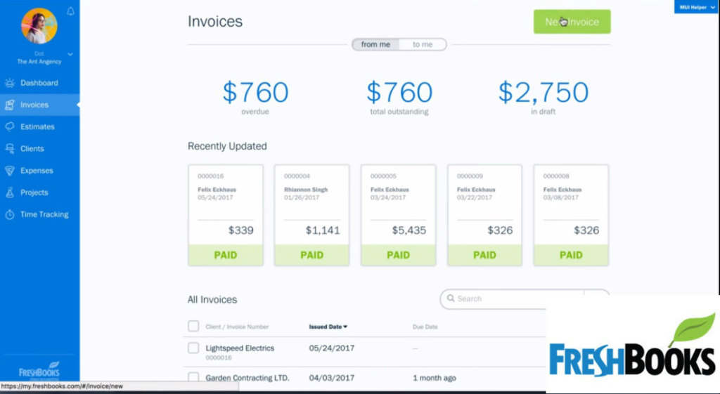
Sage 50cloud
